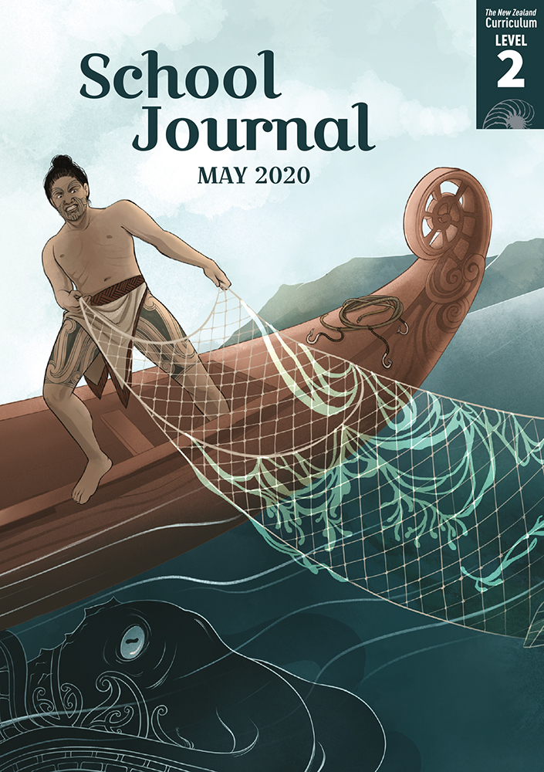

School Journal

Level 2, May 2020

**Year 4**

# Let’s Vote on It!

by Simon Cooke

The[Learning Progression Frameworks](https://curriculumprogresstools.education.govt.nz/lpf-tool) describe significant signposts in reading and writing as students develop and apply their literacy knowledge and skills with increasing expertise from school entry to the end of year 10.

## Overview

The author uses this light-hearted play to introduce ideas about voting, elections, and MMP. A monster is roaming the kingdom and causing mayhem. The characters come up with various ways to deal with the threat and then vote on the solutions. The resolution sees the problem solved peacefully through communication.

A PDF of the text is available at [www.schooljournal.tki.org.nz](http://www.schooljournal.tki.org.nz)

## Themes

* Fairness
* Problem solving
* Surprise
* Humour
* Community

## Related texts

“**I Want to Be Zippy**” SJ L2 Sept 2014 | “**A Work of Art**” SJ L2 Oct 2015 | “**Good as Gold**” SJ L2 Aug 2016 |   
“**The Race**” SJ L2 May 2017 | “**The Best Team Ever**” SJ L2 Aug 2017 | “**The Show Went On**” SJ L2 Nov 2017 |  
“**A Waste of Space**” SJ L2 Nov 2018 | “**As Easy as One, Two, Three**” SJ L2 June 2018 | “**Stop, Thief!**” *JJ* 55

## Strengthening reading behaviours (what to notice)

|  |  |
| --- | --- |
| Text structure and features | Requiring students to: |
| * Implied information or ideas (requiring readers  to infer) * Irony and ambiguity | * follow stage directions and visualise off-stage actions to make inferences about whether or not the monster is as scary as the townspeople think * make links between their prior knowledge and the characters’ actions, their dialogue, and the stage directions to understand the different traits of each character. |

|  |  |
| --- | --- |
| Vocabulary | |
| Some unusual names | Sir Hides-a-lot, Sir Speedy, Princess Biffelda, Royal Advisor, King Snooze, Mr Teddykins |
| Some antiquated phrases in keeping with fairy tales and stories about knights  Some unfamiliar words | But sire, My loyal citizens, In far-off lands, Splendid! It is I  scene, off-stage, knights, town square, flexing, destruction, wrestling |

|  |
| --- |
| Helpful prior knowledge (pre-reading and introducing the text) |
| * Plays have certain structures and features. * Fairy tales have conventions, and authors can play with these conventions for humorous effect. * Decisions can be made through voting and electioneering. |

**Possible reading and writing purposes**

* Think about and compare their own and others’ views about this play and the problem it included
* Find out how voting helps people make decisions
* Identify the author’s purpose and consider how he makes the reader think about this

See *Effective Literacy Practice in Years 1–4* for suggestions on using this text with your students ([Approaches to teaching reading](http://literacyonline.tki.org.nz/Literacy-Online/Planning-for-my-students-needs/Effective-Literacy-Practice-Years-1-4/Approaches-to-teaching-reading)) and for information about teaching comprehension strategies ([Building comprehension](http://literacyonline.tki.org.nz/Literacy-Online/Planning-for-my-students-needs/Effective-Literacy-Practice-Years-1-4/Building-comprehension) and [Text processing strategies](http://literacyonline.tki.org.nz/Literacy-Online/Planning-for-my-students-needs/Effective-Literacy-Practice-Years-1-4/Text-processing-strategies)).

## Possible curriculum contexts

This text has links to level 2 of the New Zealand Curriculum in:**[ENGLISH](http://nzcurriculum.tki.org.nz/The-New-Zealand-Curriculum/English)**[**SOCIAL SCIENCES**](http://nzcurriculum.tki.org.nz/The-New-Zealand-Curriculum/Social-sciences)[**THE ARTS: DRAMA**](https://nzcurriculum.tki.org.nz/The-New-Zealand-Curriculum/The-arts)

## Understanding progress

The following aspects of progress are taken from the [Learning Progression Framework](https://curriculumprogresstools.education.govt.nz/lpf-tool/)s and relate to the specific learning tasks below. See the LPFs for more about how students develop expertise and make progress in these aspects:

* Reading for literary experience
* Making sense of text: using a processing system
* Reading to organise ideas and information for learning
* Using writing to think and organise for learning.

## Strengthening understanding through reading and writing

The *School Journal* provides rich texts that can be returned to many times. The following suggestions are based on the premise that rereading the text is a fundamental part of developing students’ understanding and reading skills. **Select from and adapt** them, according to your students’ strengths, needs, and experiences.   
Note: Most of these activities lend themselves to students working in pairs or small groups.

* Think, pair, share, and compare what the students thought of this play. List some aspects you would like them to focus on, for example, something funny, sad, or surprising; something that made them wonder; their most liked character; their least liked character; a connection they had; a word they didn’t know; or a phrase they enjoyed. Then ask them to think about what they have selected. Have them share and discuss their reasons with a partner, then have them compare these with those of the group or another pair.
* Retell the play as a story. Divide the pages for pairs to find the main events and any important vocabulary that relates to these events. Each pair could then take turns to tell the story.
* Draw a character and find clues in the play to record what the character is like (behaviours and actions). Students could add their own words that help describe the character.
* Compare the different suggestions using the **Problem–solutions** template provided. The students can express their own view about the outcome and suggest something they might have done.
* Ask the students to think about what this play is mainly about. If they just say “voting”, prompt them to consider what the author wanted them to feel. Draw their attention to certain parts, for example, on page 26, the king’s reaction to houses being knocked down then his reaction to the statue being damaged; on page 28, the various suggestions including the Royal Advisor’s suggestion; and on page 32, when the monster tells them about his glasses. It may help for the students to walk in the shoes of a character to consider the themes in the story: community, fairness, and problem solving.
* Locate the information about voting, discussing anything that is unclear and relating this to a situation where students or their families vote on something. You might need to explore the concept of totalling and use materials to show how this works.
* Clarify the meaning of any unfamiliar words or phrases. You might select some words for the students to record, find the definition of, and draw a picture of (or write synonyms). Encourage them to use a dictionary or thesaurus. English language learners could write translations in their first language.
* For more ideas and strategies to support English language learners, see [ESOL Online](https://esolonline.tki.org.nz/).

“Let’s Vote on It!” Problem–solutions

|  |
| --- |
| The problem is: |

|  |  |  |  |  |
| --- | --- | --- | --- | --- |
|  | Wants to |  |  | **What happened next?** |
|  |  |  |  |  |
| Wants to |  |  |  |  |
|  |  |  |  |  |
|  | Wants to |  |  |  |
|  |  |  |  |  |
|  | Wants to |  |  |  |

|  |
| --- |
| What do you think about what happened? |